**F****Beat the Winter Blues**

**All Day Bingo**

**Sat, Feb. 17th**

**Doors open at 9am ~ Games begin at 11am**

***Hosted by and proceeds benefit:***

**Glen Burnie Volunteer Fire Company**

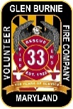**1012 Bell Avenue – Glen Burnie, MD 21060**

**410-793-2709**

**Admission $40 Includes:**

**9 card / 35 game pack, 1 jackpot strip,**

**1 of each bonanza and luncheon.**

**Early Birds, Quickies & Specials sold separate**